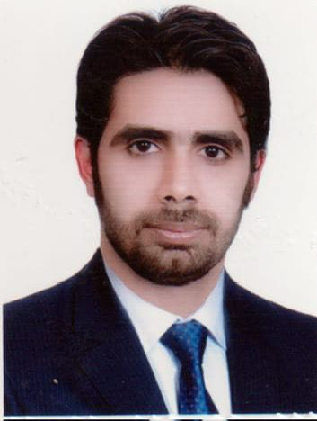
Biography
CV
Personal Information:
Full Name and Surname: Yasser Adnan Mohan.
Place and date of birth: Iraq / Karbala.
Marital Status: Single.
Current residential address: Karbala – Hindi.
Phone and WhatsApp number: (07721498610).
Approved Email :yaseradnan994@gmail.com
Languages I am fluent : Arabic
First: Information of scientific certificates, scientific title and place of work
• He holds a bachelor's degree in law, University of Karbala
• He holds a Master of Laws degree from the Islamic University of Lebanon
• Teaching at Al-Safwa University College, Department of Law, the date of fatigue 2023.
• Legal subjects you have taught
▪ History of the law
▪ Human Rights
▪ Democracy
▪ Crimes of the Baath regime
▪ Supervising research undergraduate students

