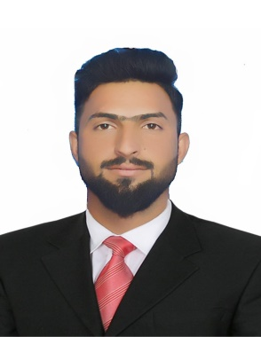
Biography
CV
Personal Information:
Full Name and Surname: Walaa Fakhri Ali Abd.
Place and date of birth: Iraq / Babylon - 5/10/1992.
Marital Status: Married.
Current residential address: Babylon / Hilla.
Phone and WhatsApp number: (07714474378).
Approved Email :walaa.900800@gmail.com
Languages I am fluent : Arabic

First: Information of scientific certificates, scientific title and place of work
• He holds a bachelor's degree in law, Islamic University of Babylon 2016/2017.
• Master's degree in public law from Iran, University of Qom 2022-2023 .
• PhD student
• Teaching at Al-Safwa University College, Department of Law, the date of fatigue 23/8/2023.
• He holds the scientific title of assistant lecturer issued by Al-Safwa University College under Administrative Order 9669
• Legal subjects you taught:
▪ Human rights.
▪ Democracy.
▪ Crimes of the Baath regime

Current and former administrative and scientific positions and committees
❖ Member of the investigative committee at the Faculty of the University Elite.
❖ Member of the examination committees in the Department of Law.
❖ Member of the Iraqi Bar Association
❖ Member of the Iraqi Academics Syndicate
Fourth: Conferences, seminars and scientific seminars in which they participated:
❖ An educational seminar on 24/1/2023 on (the legal framework for cross-border crimes, drug crimes, for example), which targeted a number of activists, civil society organizations and security services
❖ A workshop on 13/2/2023 on (crimes of genocide and crimes against humanity), which targeted a number of employees, media and clerics

❖ Workshop on 12/4/2024 on (International Criminal Court), which targeted a number of activists and civil society organizations
❖ A conference on sustainable development on 18/7/2023 targeting a number of academics, lawyers, activists, education and security services

❖ A workshop on 7/8/2023 on (Human Trafficking Law), which targeted a group of organizations, the Committee to Combat Human Trafficking, clerics, the Human Rights Commission and tribal sheikhs

❖ Accepting a research and an invitation to deliver it at the third integrated scientific conference of the College of Imam Al-Kazim, Diwaniyah Departments with the Cambridge International Journal, tagged (Academic Thought is a means for the growth and development of societies), which was held physically on 9/20/2023

