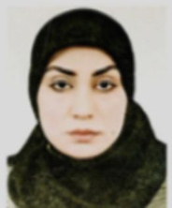
Biography
CV
Personal Information:
Full Name and Surname: Hind Muhannad Abd Marza Al-Dabil.
Place and date of birth: Iraq / Karbala - 1984.
Marital Status: Married.
Current residential address : Karbala / Husseiniya .
Phone & WhatsApp: (07735275983 ) .
Certified Email : hind.muhanned@alsafwa.edu.iq
Languages I am fluent : Arabic

First: Information of scientific certificates, scientific title and place of work

• Name of the university granting the bachelor's degree University of Karbala
• Name of the university granting the master's degree University of Karbala
• The name of the university granting the doctorate degree Al-Alamein Institute for Graduate Studies Najaf supervision
• Scientific Title Lecturer Doctor Degree PhD Law Public Jurisdiction Private Law Exact Jurisdiction Private International Law
• Subjects taught
➢ Commercial Papers
• Places where he worked at Al-Safwa University College

