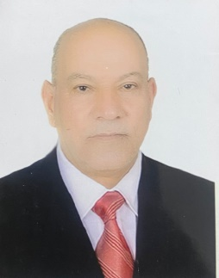
Biography
CV
Personal Information:
Full name and surname: Makki Kazem Abdul Abbas Al-Jubouri.
Place and date of birth: Iraq / Karbala - 1962.
Marital Status: Married.
Current residential address: Karbala / Indian district.
Phone and WhatsApp number: (07802554219).
Approved Email :mkyaljbwrya@gmail.com
Languages I am fluent : Arabic

First: Information of scientific certificates, scientific title and place of work
• He holds a bachelor's degree in law, Ahl al-Bayt University
• He holds a master's degree in public law from Iran, Al-Mustafa International University
• He holds a doctorate degree in public law from Iran, Al-Mustafa International University
• Teaching at Al-Safwa University College, Department of Law.
• He holds the scientific title of Assistant Doctor issued by Al-Safwa University College.
• Legal subjects you taught:
▪ Constitutional
▪ Implementation

Current and former administrative and scientific positions and committees
❖ Employee of the Qa'qaa Public Establishment in 1986
❖ Director of the Northern and Southern Babylon Archives / Romanian Company for Land Reclamation in 1995
❖ Mahmoudia Site Manager
❖ Director of the prefabricated building complex in Karbala and Najaf
❖ Manager of Al-Wafa factory stores for Al-Fares Company
❖ Director of the Legal Department in the Holy Province of Karbala / 2010
❖ Assistant Governor of Karbala for Administrative Affairs 2011-2017
❖ Legal Advisor to the Governor of Holy Karbala 2017-2022
❖ Member of the investigative committee at the Faculty of the University Elite.

