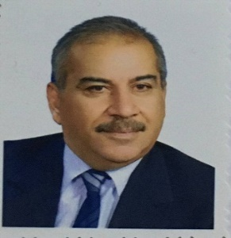
Biography
CV
Personal Information:
Full name and surname: Kamel Kazem Abdullah Najm Al-Damerji.
Place and date of birth: Iraq / Karbala - 1/11/1961.
Marital Status: Married.
Current residential address: Karbala / Al-Hussein neighborhood.
Phone and WhatsApp number: (07728207691).
Approved Email :kame.kazem@alsafwa.edu.iq
Languages I am fluent : Arabic

First: Information of scientific certificates, scientific title and place of work
• He holds a bachelor's degree in law from Ahl al-Bayt University
• He holds a master's degree in private law from the Islamic University of Lebanon
• He holds a PhD in Private Law from the Islamic University of Lebanon.
• Teaching at Al-Safwa University College, Department of Law.
• He holds the scientific title of lecturer issued by Al-Safwa University College .
• Legal subjects you taught:
▪ Evening contracts
▪ Implementation
▪ History of the law
▪ Research Origins
▪ General Penal Code.
▪ Work and warranty .
▪ Supervising the writing of graduation research.

Current and former administrative and scientific positions and committees
❖ Member of the examination sub-committees at Al-Safwa University College, Department of Law, for several years.
❖ Member of the Scientific Committee in the Department of Law, Faculty of Al-Safwa University.
❖ Member of the dozens of investigative committee in the Faculty of the elite university.
❖ Member of the graduation research discussion committees in the Department of Law.
❖ Representative of the Academics Syndicate at Al-Safwa University College
Third - theses research and scientific articles:
• Professional commitment to insight into electronic contracts in the Journal of the Message of Law, Karbala University
• The consumer's right to withdraw from the contract Journal of the College of Law, Al-Nahrain University
• The contract of information automation and its negotiation stages

