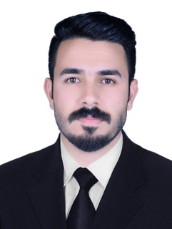
Biography
CV
Personal Information:

Full Name and Surname: - Ali Abdul Karim Nouri Mahawi Al-Khaiqani
Date of birth: 1 \ 1 \ 1994
Marital Status: Married.
Current residential address: Holy Karbala Mahalla: 686 Alley: 22 House number:
Phone Number :- 07805088252
Email :- alinoory199311@gmail.com
Languages I am fluent in: Arabic

First: Information of scientific certificates, scientific title and place of work
• Name of the university granting the bachelor's degree: - University of Karbala
• The name of the university granting the master's degree: - Al-Mustafa International University
• The donor country for the last certificate: - Iran
• Scientific Title :- Assistant Lecturer Certificate :- Master
• General Jurisdiction: General Law. Exact Jurisdiction: Criminal Law and Criminology
• Teaching at Al-Safwa University College, Department of Law
• Legal subjects you have taught :
➢ Human Rights
➢ Democracy

