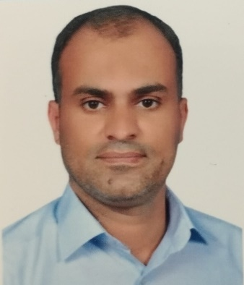
Biography
CV
Personal Information:

Full Name and Surname: Adnan Ali Majed Al-Jubeir
Place and Date of Birth : Baghdad - 1982
Current Residential Address : Karbala
Phone & Whatsapp Number :: 07718313142
Mail : adnanaljabry1982@gmail.com
Languages I am fluent : Arabic

First: Information of scientific certificates, scientific title and place of work
• Holds a bachelor's degree in law / College of Law, University of Karbala
• He holds a master's degree in public law / Al-Alamein Institute for Graduate Studies
• PhD student
• Work : Teaching at Al-Safwa University College / Department of Law
• Legal subjects you taught.
➢ Human Rights
➢ Administrative Judiciary
➢ International organizations

Second: Conferences, seminars and scientific seminars in which they participated:
• He holds a certificate of modern teaching methods, University of Karbala
• Holds a certificate of training of trainers TOT / Al-Rafidain Center for Human Development
• Training and development of administrative and legal cadres in the Holy Karbala Provincial Council, the Directorate of Education in the Holy Karbala Province and the Department of Youth and Sports in Holy Karbala

