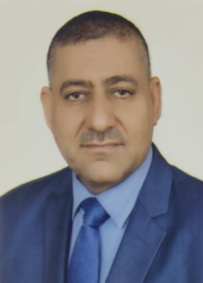
Biography
CV
Personal Information:
Triple name and surname: Abbas Shattul Hamoud Al-Shammari.
Place and date of birth: Iraq / Babylon - 1966.
Marital Status: Married.
Current residential address: Babylon.
Phone and WhatsApp number: (07809025632).
Authorized Email :abbasshatoo99qwe@gmail.com
Languages I am fluent : Arabic

First: Information of scientific certificates, scientific title and place of work
• He holds a bachelor's degree in law, University of Babylon, first session, 1998
• Master's degree in Law from the Islamic University of Lebanon 2021
• PhD in Law from the Islamic University of Lebanon 2023
• Teaching at Al-Safwa University College, Department of Law, the date of fatigue 2023.
• Legal subjects you taught:
▪ Criminology and Punishment
▪ Forensic Medicine and Investigation
▪ Supervising research undergraduate students
Books & Research
• Research entitled The Impact of the Right of Veto on the Proceedings of the International Criminal Court
• Criminal liability of a private person
• The role of the United Nations in maintaining international peace and security in our contemporary world
Participating in conferences, seminars and scientific seminars
• Falsification of official documents and documents related to student affairs
• The right to peaceful demonstration
• How to file civil lawsuits
• The legal effects of withdrawing the hand of an employee in Iraqi law

