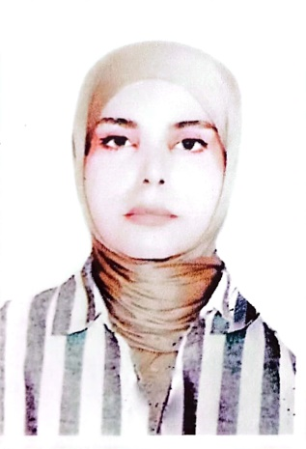

Biography
CV
Personal Information:
Full Name and Surname: Roaa Fadel Hamza Suoud Al-Azzawi .
Place and date of birth: 10/4/1986/Baghdad_Karkh.
Marital Status: Single.
Current residential address: Babylon - Musayyib.
Phone and WhatsApp number: (009647759894899).
Approved Email : Lawyerroaa90@gmail.com
Languages I am fluent in: : I am fluent in Arabic, English, Persian

First: Information of scientific certificates, scientific title and place of work
• He holds a bachelor's degree in law, University of Karbala
• She holds a master's degree from Azad Isfahan University in 2023
• PhD student in Iran Alama Tabatabai International Government University 2024
• Teaching at Alsafwa University College
• Member of the examination committee
• Legal subjects you have taught
▪ Human Rights
▪ Democracy
Supervising research undergraduate students

