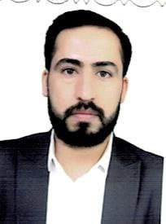
Biography
CV
Personal Information:

Full Name and Surname: - Dr. Iyad Saud Hashem Abdul Masoudi
Date of birth: 1988
Mother's Name:- Rahma Jassim Hussain
Governorate of residence: Karbala Mahalla: Husseiniya
Email :- ayad-saud@alsafwa.edu.iq
Phone Number :- 07810537268
Languages I am fluent : Arabic

First: Information of scientific certificates, scientific title and place of work
• He holds a bachelor's degree in law from the University of Karbala
• He holds a master's degree in law from the University of Karbala
• He holds a PhD in law from the University of Karbala
• Academic Title : Lecturer Degree : PhD
• Places where he worked from and to: Al-Safwa University College from 1/9/2014 until now.
• General Jurisdiction: Public Law Exact Jurisdiction: Administrative Law
• Legal subjects you have taught
➢ Administrative Law
➢ Penal Code, General Section,
➢ Public Finance ,
➢ legal research
➢ Principles of criminal investigation and forensic medicine
➢ Labor and Security Law
➢ Human Rights
➢ Democracy
➢ Criminology and Punishment
➢ Introduction to the study of Islamic law.
Current and former administrative and scientific positions and committees
1- Member of the examination committee for ten years.
2- Supervisor of a master's thesis at the International Sofa University.
3- Supervising and discussing graduation research for fourth stage students.

Third - theses research and scientific articles:

1- The role of local administrative control in protecting the environment, a comparative study.
2- The effects of extending the public works contract on the contractor with the administration, a comparative study.
3- Legal regulation of sovereign wealth funds in Iraq, a comparative study.
4- The effects of extending the public works contract on the contracting administration, a comparative study.
5- The role of international intervention in assigning power to Iraq as a model.

