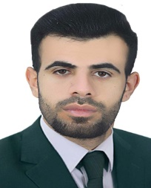
Biography
CV
Personal Information:
Full name and surname: Ahmed Saleh Shalal Al-Mahdawi.
Place and date of birth: Iraq / Babylon.
Marital Status: Single.
Current residential address: Babylon - Musayyib.
Phone and WhatsApp number: (07735070721).
Approved Email : Ahmed.salih@alsafwa.ed,iq
Languages I am fluent : Arabic

First: Information of scientific certificates, scientific title and place of work
• He holds a bachelor's degree in law, University of Karbala
• Master's degree in public law
• Teaching at Al-Safwa University College, Department of Law, the date of fatigue 2023.
• Legal subjects you have taught
▪ Human Rights
▪ Democracy
▪ Crimes of the Baath regime

